SUBCOURSE EDITION
AD0497 A

DEPLOYMENT OF MAST GROUP,
HYDRAULIC-PNEUMATIC OA-9054(V)4/G
(PATRIOT COMMUNICATIONS SYSTEM)

(SOJT)

TABLE OF CONTENTS

Title Page

Warning ii

Preface iii

Information for Student iv

Information for SOJT Monitor vi

Testing Section vii

Lesson I 1

Lesson II 9

The following tasks support this document: 113-596-1071 and 113-596-7054.

i

Whenever pronouns or other references denoting gender appear in this document, they are written to refer to either male or female unless otherwise indicated.

WARNING

HIGH VOLTAGE IS PRESENT WHEN
INTERVEHICULAR CABLES ARE DEPLOYED
AND RF POWER IS APPLIED.

1. DO NOT move vehicle with mast raised.

2. DO NOT extend mast in high winds.

3. Extend mast only high enough to allow communications.

4. Keep a weather watch. Retract mast if squalls or thunderstorms are observed or reported in area.

5. Immediately, retract both mast if personnel in shelters (ECS/CRG/ICC) tell you that status monitor panel alarms (TM 9-1430-603-10) is on.

6. There are many trip hazards on the mast group ..... use care.

7. DO NOT exceed maximum load on antenna protective covers -600 lbs.

ii

PREFACE

1. This Supervised On-the-Job Training (SOJT) subcourse contains tasks dealing with the deployment of Mast Group OA-9054(V) 4/G. It gives you, the crew members, valuable training in emplacement, operation, and deploying the mast group with the various assemblages that comprise an operable radio system. It is designed to provide the individual teams with hands-on equipment training which will be required in the unit.

2. Before attempting this SOJT option, you must be familiar with information found in "The Operators Operation and PMCS Manual." Assistance will be made available for the tasks on which you will be tested. The Operators Operation and PMCS Manual should have been provided to you, along with this subcourse. If not, request it from the following address: Commander, USATSC, ATTN ATIC-ETI-SS, Ft Eustis, VA 23604.

iii
INFORMATION FOR STUDENT

1. This SOJT option contains 13 tasks dealing with the deployment of the OA-9054(V) 4/G Hydraulic-Pneumatic Mast Group which requires a 3-member crew to install.

2. Before attempting this SOJT option, you must be familiar with the Operators Operation and PMCS Manual, you will be assigned an SOJT monitor to assist during the practical exercise and administer the performance test.

3. The tasks on which you will be tested are described in the objective which precedes the training instructions.

4. Make sure your unit commander and SOJT monitor are provided an opportunity to read pages of this booklet containing information for them.

5. Material in this lesson is referenced from TM 11-5895-368-12&P.

INFORMATION FOR SOJT MONITOR

1. Supervising the Training. This SOJT subcourse, Deployment of Mast Group OA-9054(V) 4/G, should be monitored by an individual who is skilled in deploying the mast group. The SOJT monitor are responsible for supervision of the learner. If crew does not satisfactorily complete tasks after two attempts, they should be given ample time to review the test and retested at the monitor's discretion.

a. Provide crew members with assistance and guidance during the practice phase of training.

b. Insure the crew has the required text, Operators Operation and PMCS Manual and equipment necessary for both practical exercises and testing.

c. Insure the crew members understand the training objectives.

2. Testing the Learner.

a. You are not to provide any guidance or assistance during the graded portion of the test.

b. Insure the crew meets the time requirement listed in the standards of the objective.

c. Specific instructions for performance are located on page vii of this subcourse booklet.

vi

TESTING SECTION

INSTRUCTIONS FOR SOJT MONITOR

1. Provide the crew members with all material required.

2. The shelters used will be roadmarched to testing site.

3. Make sure the learner understands what is required to pass the test prior to beginning the test. Each task will be tested separately.

4. Make sure the crew members do their own work.

INSTRUCTIONS FOR LEARNER

1. This test checks your ability to perform 13 tasks covering the deployment of the OA-9054(V) 4/G Mast Group.

2. Make sure you understand the test objectives before beginning the test.

vii

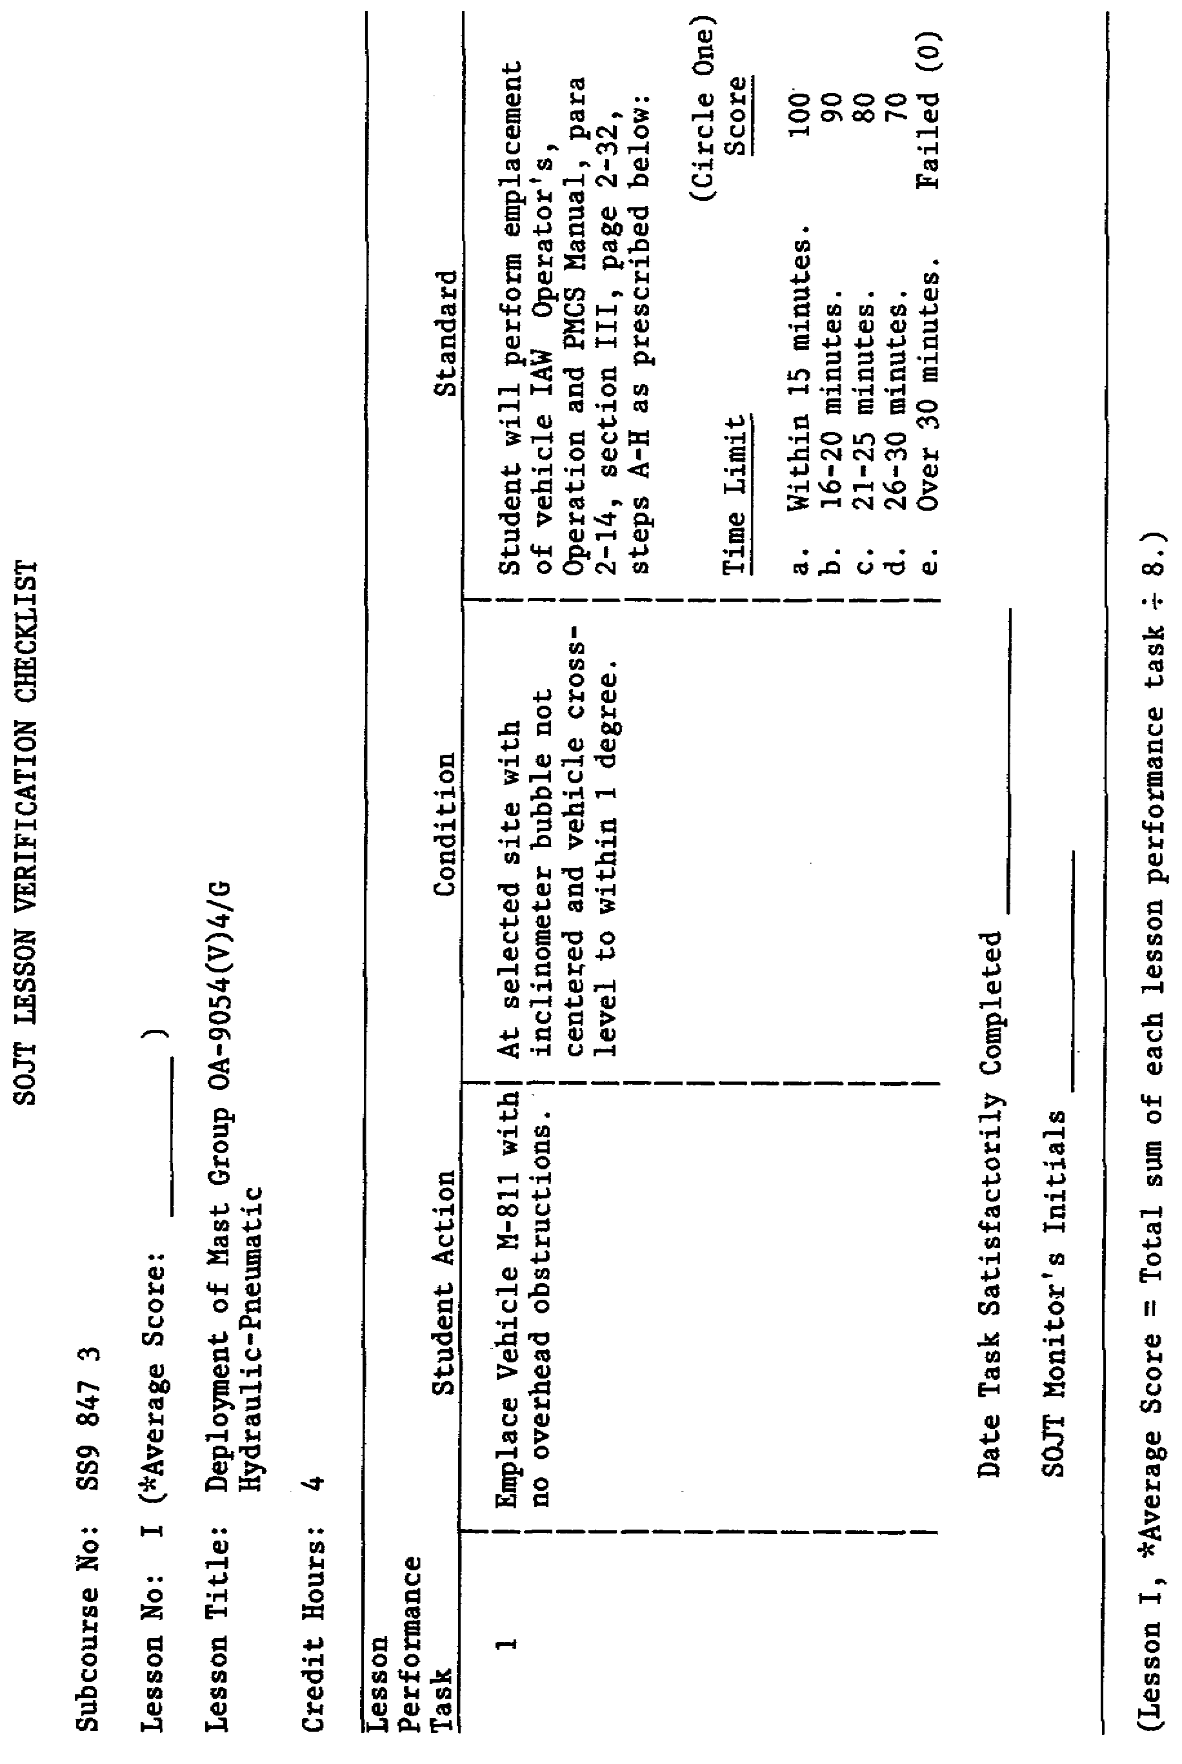
1

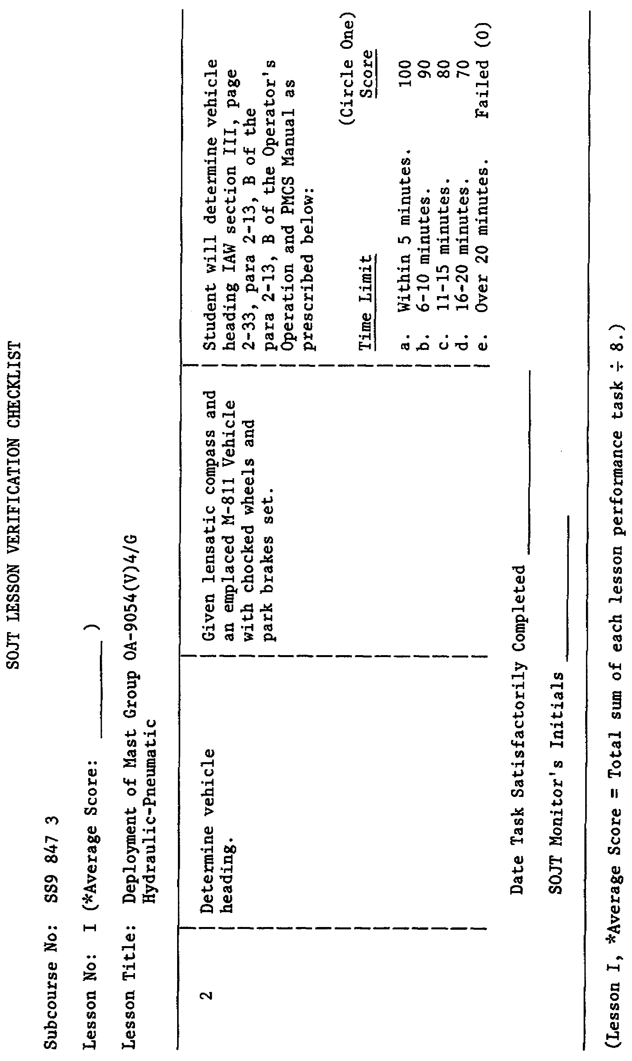
2

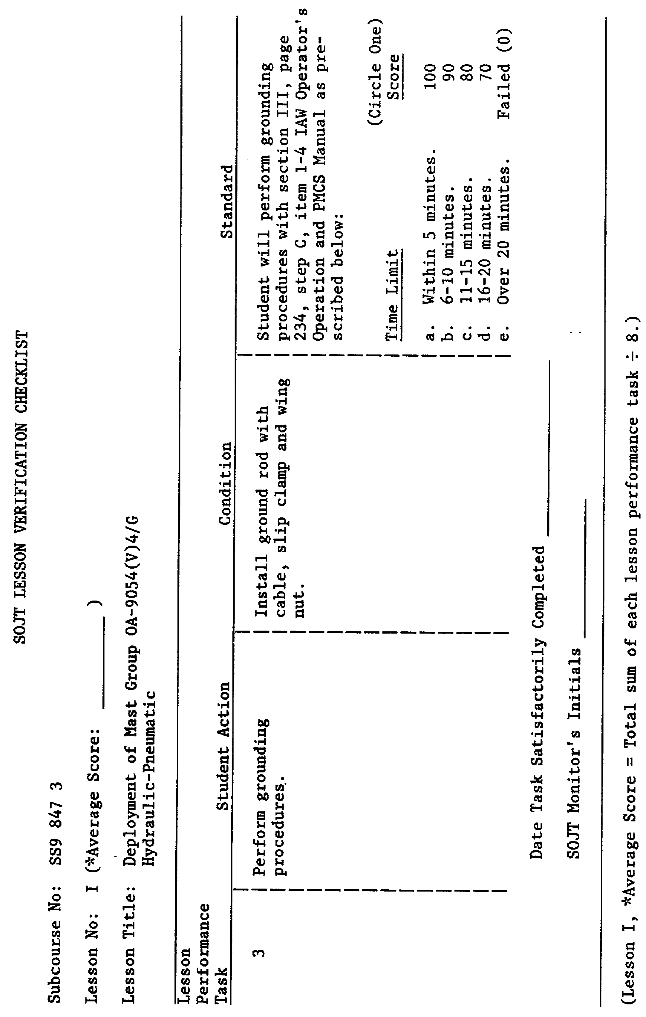
3

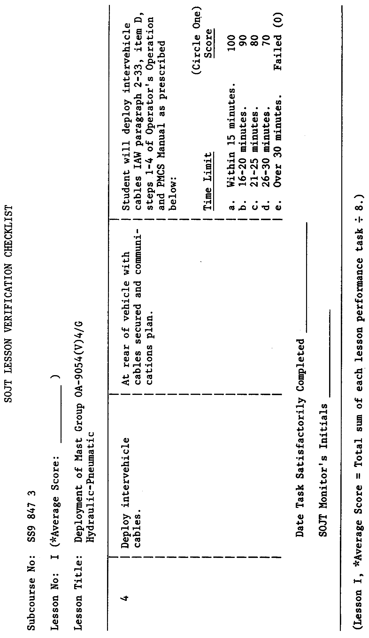
4

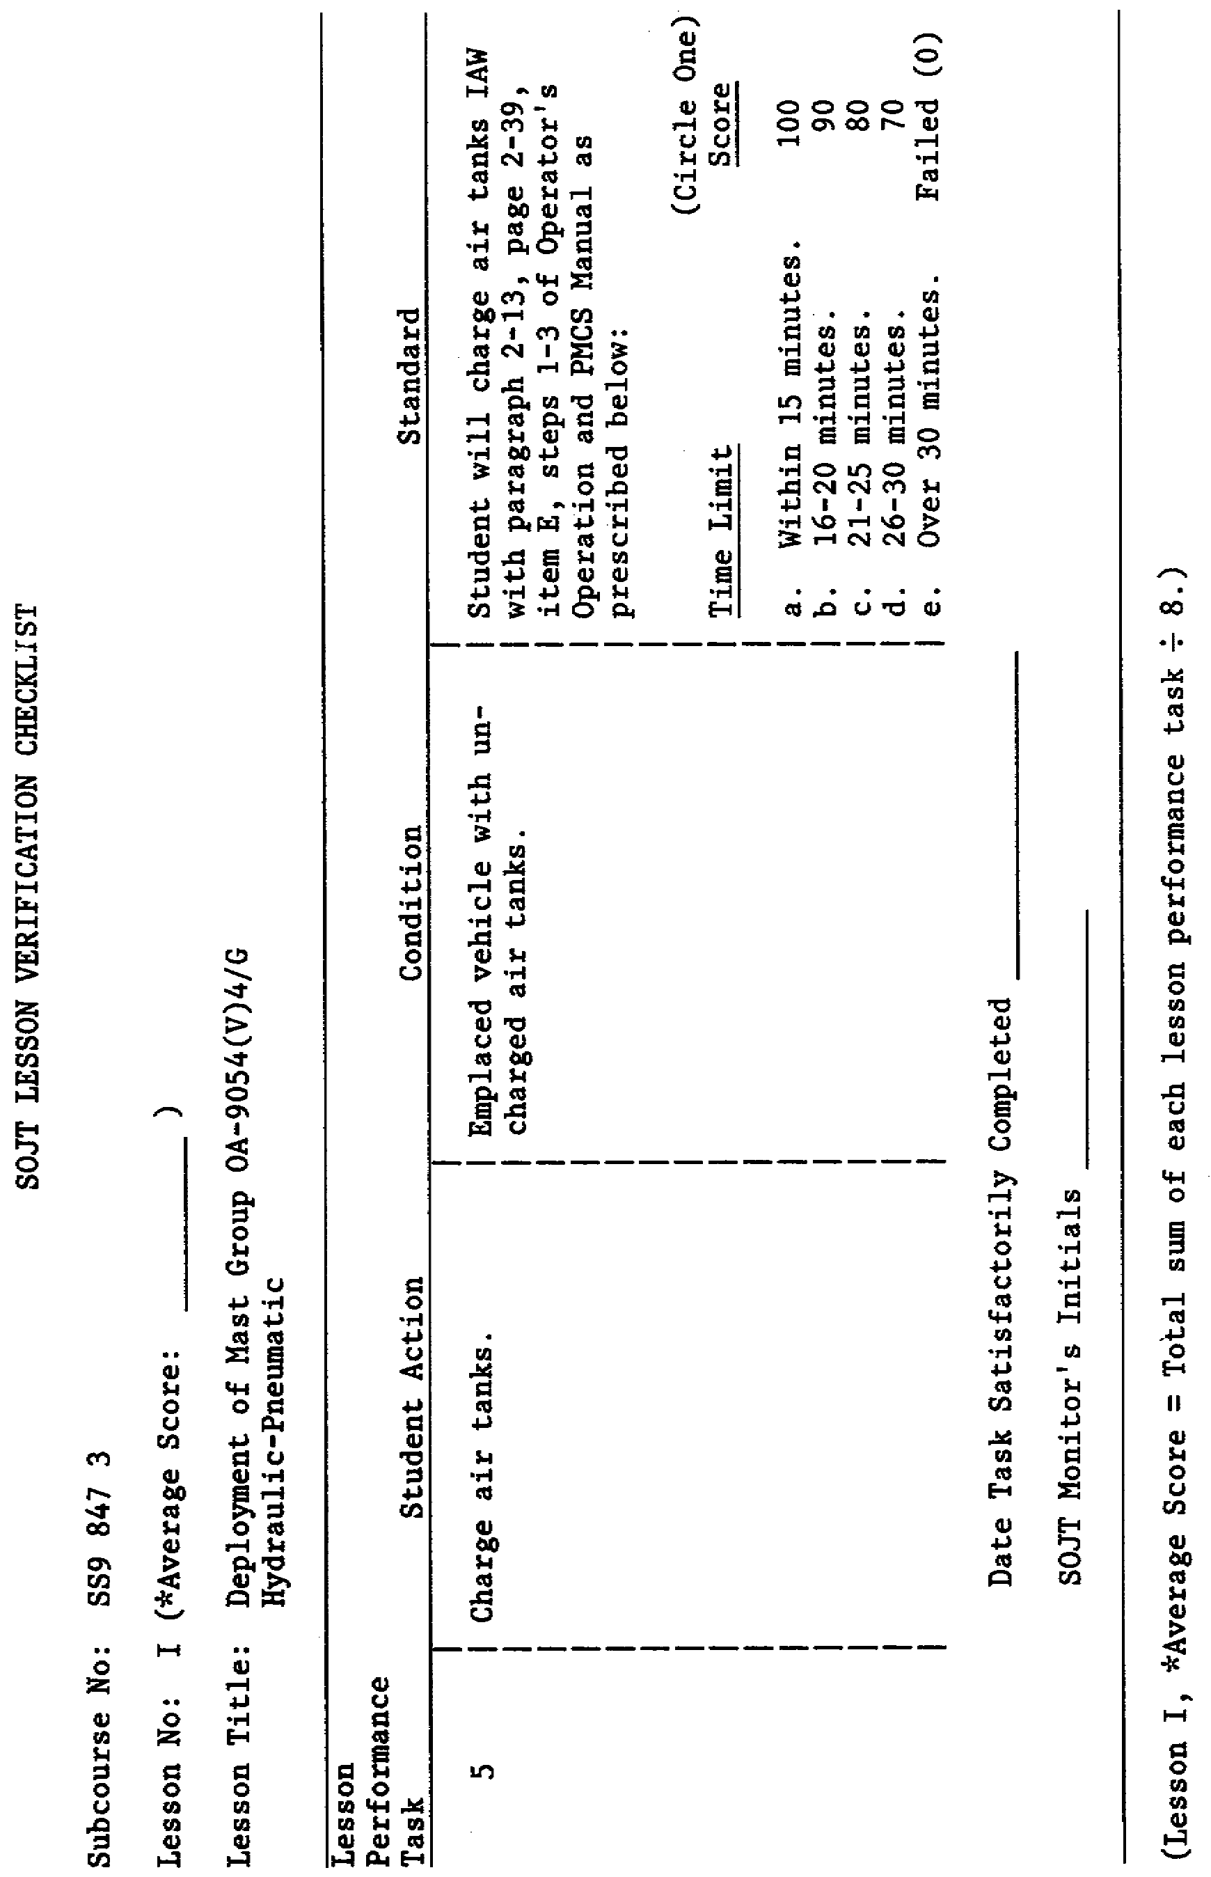
5

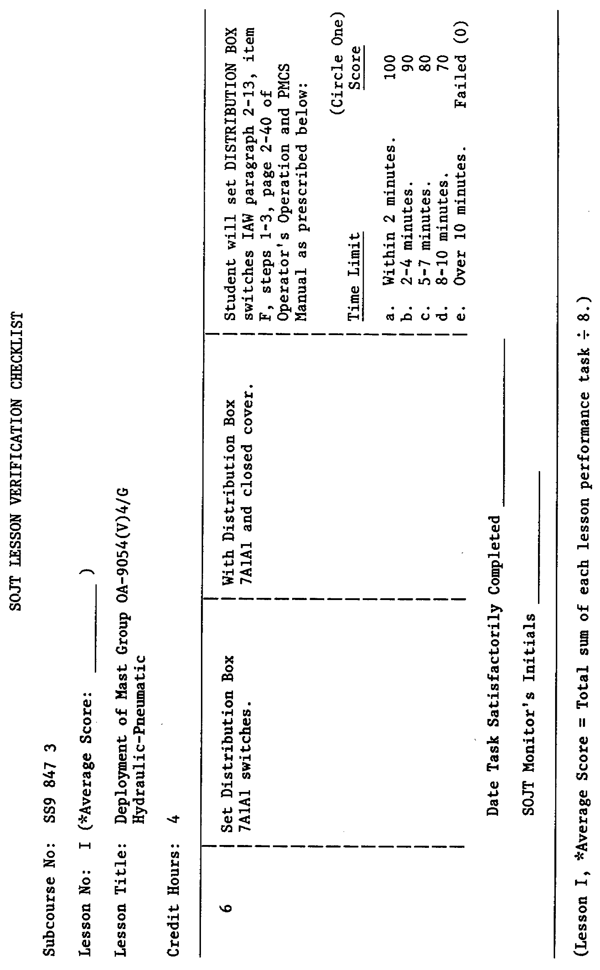
6

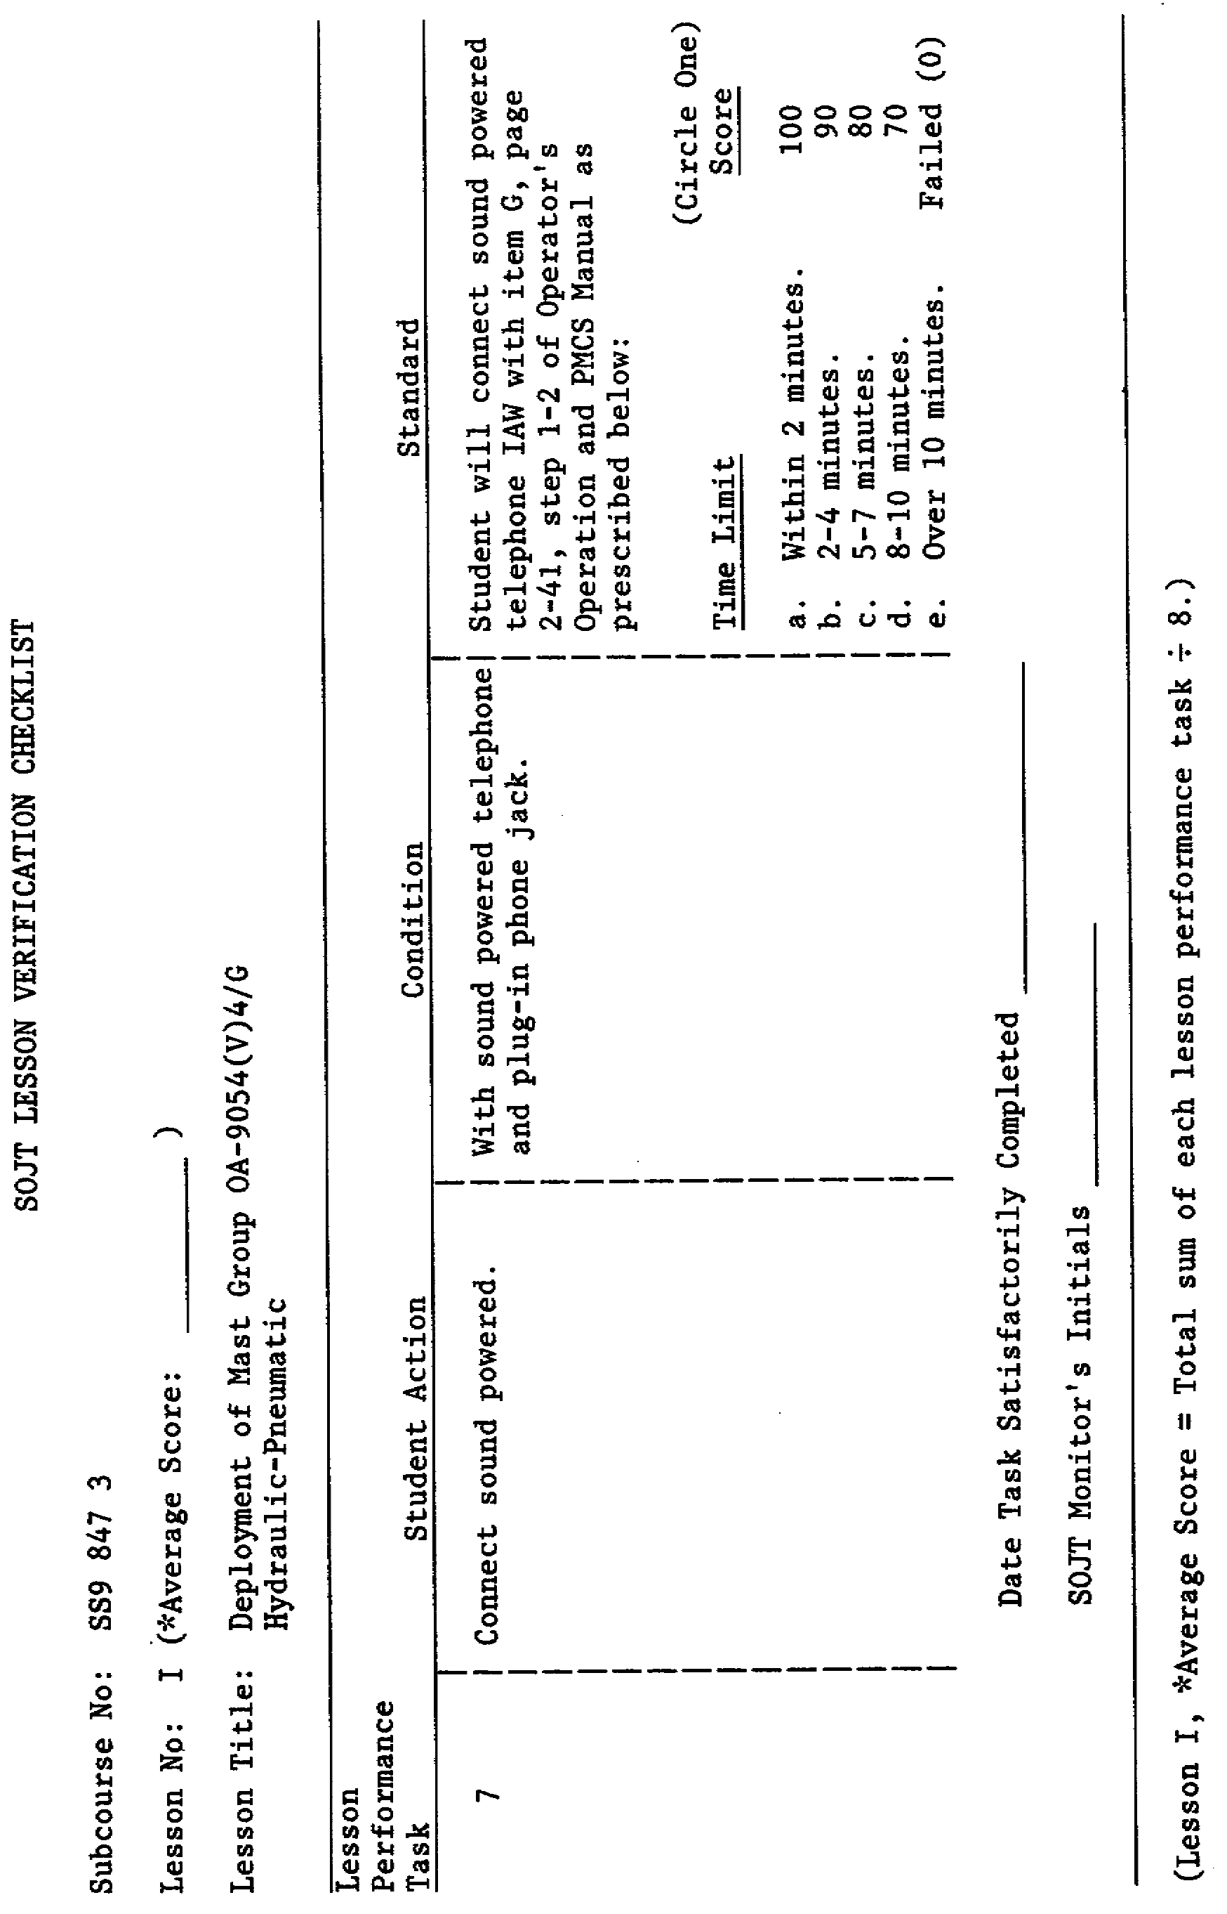
7

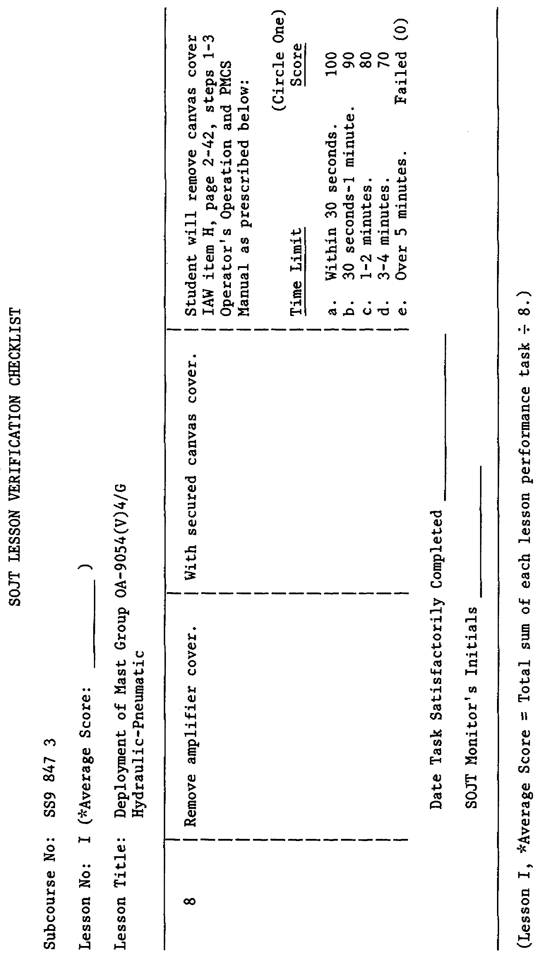
8

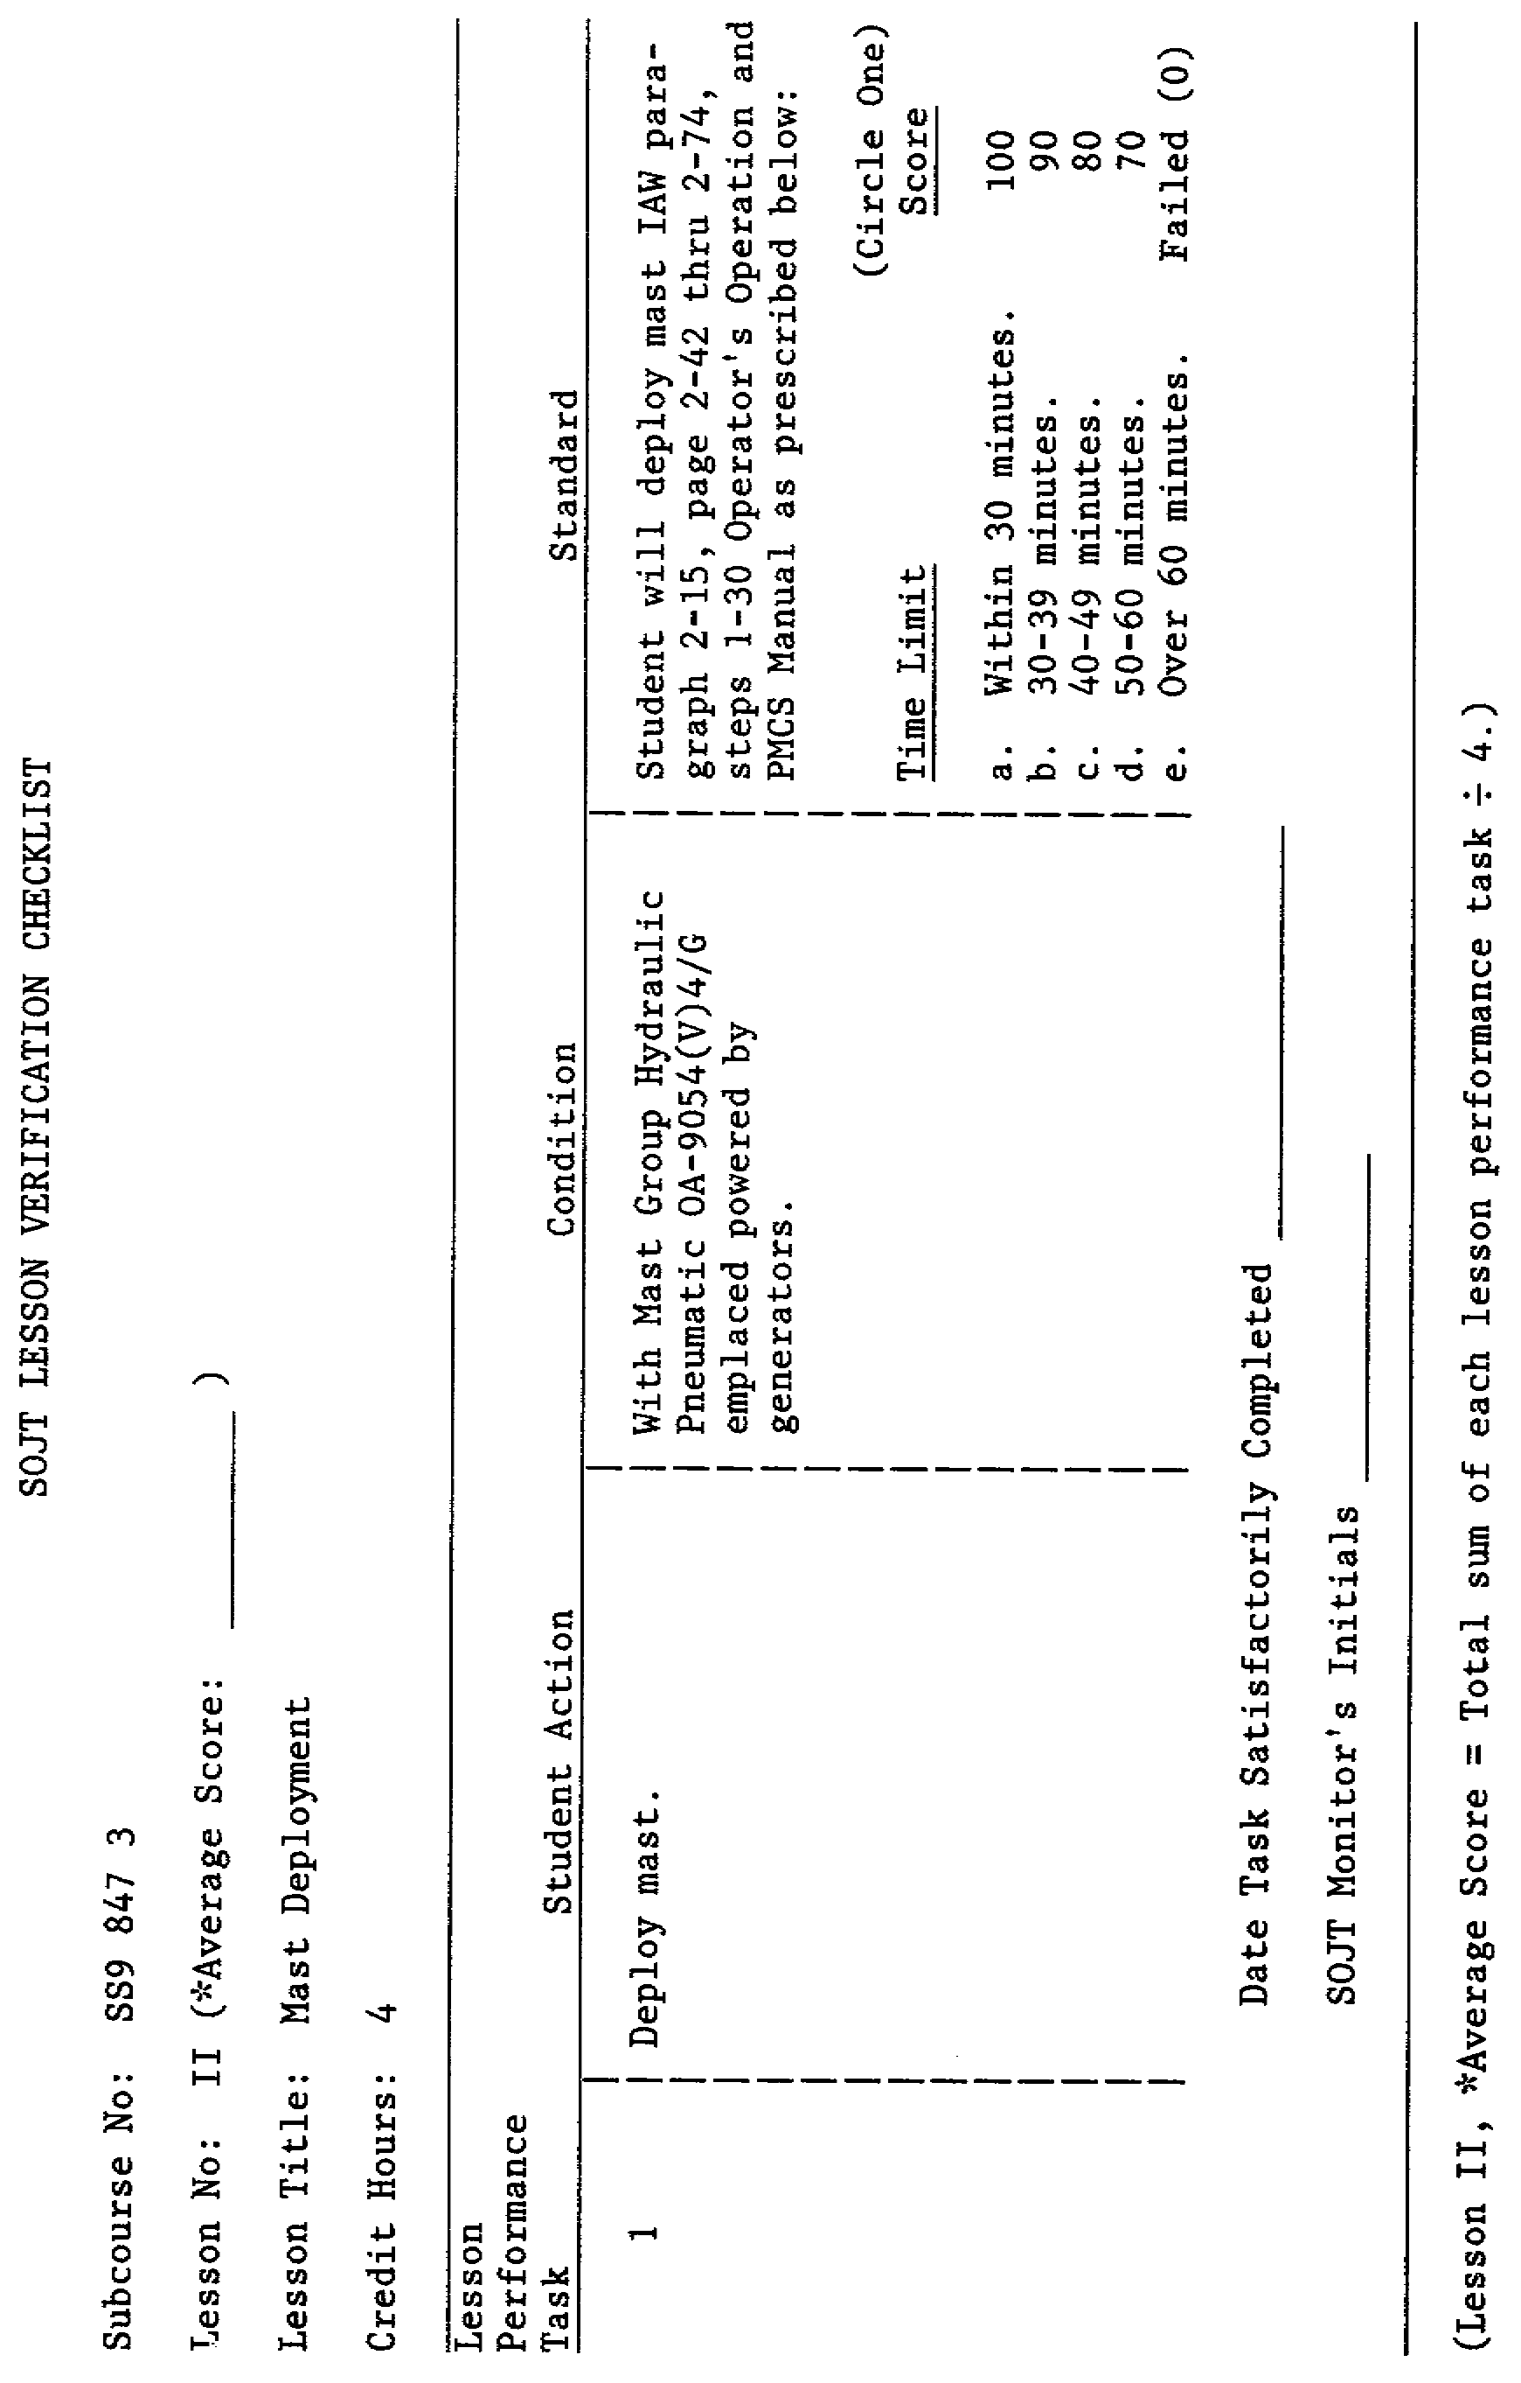
9

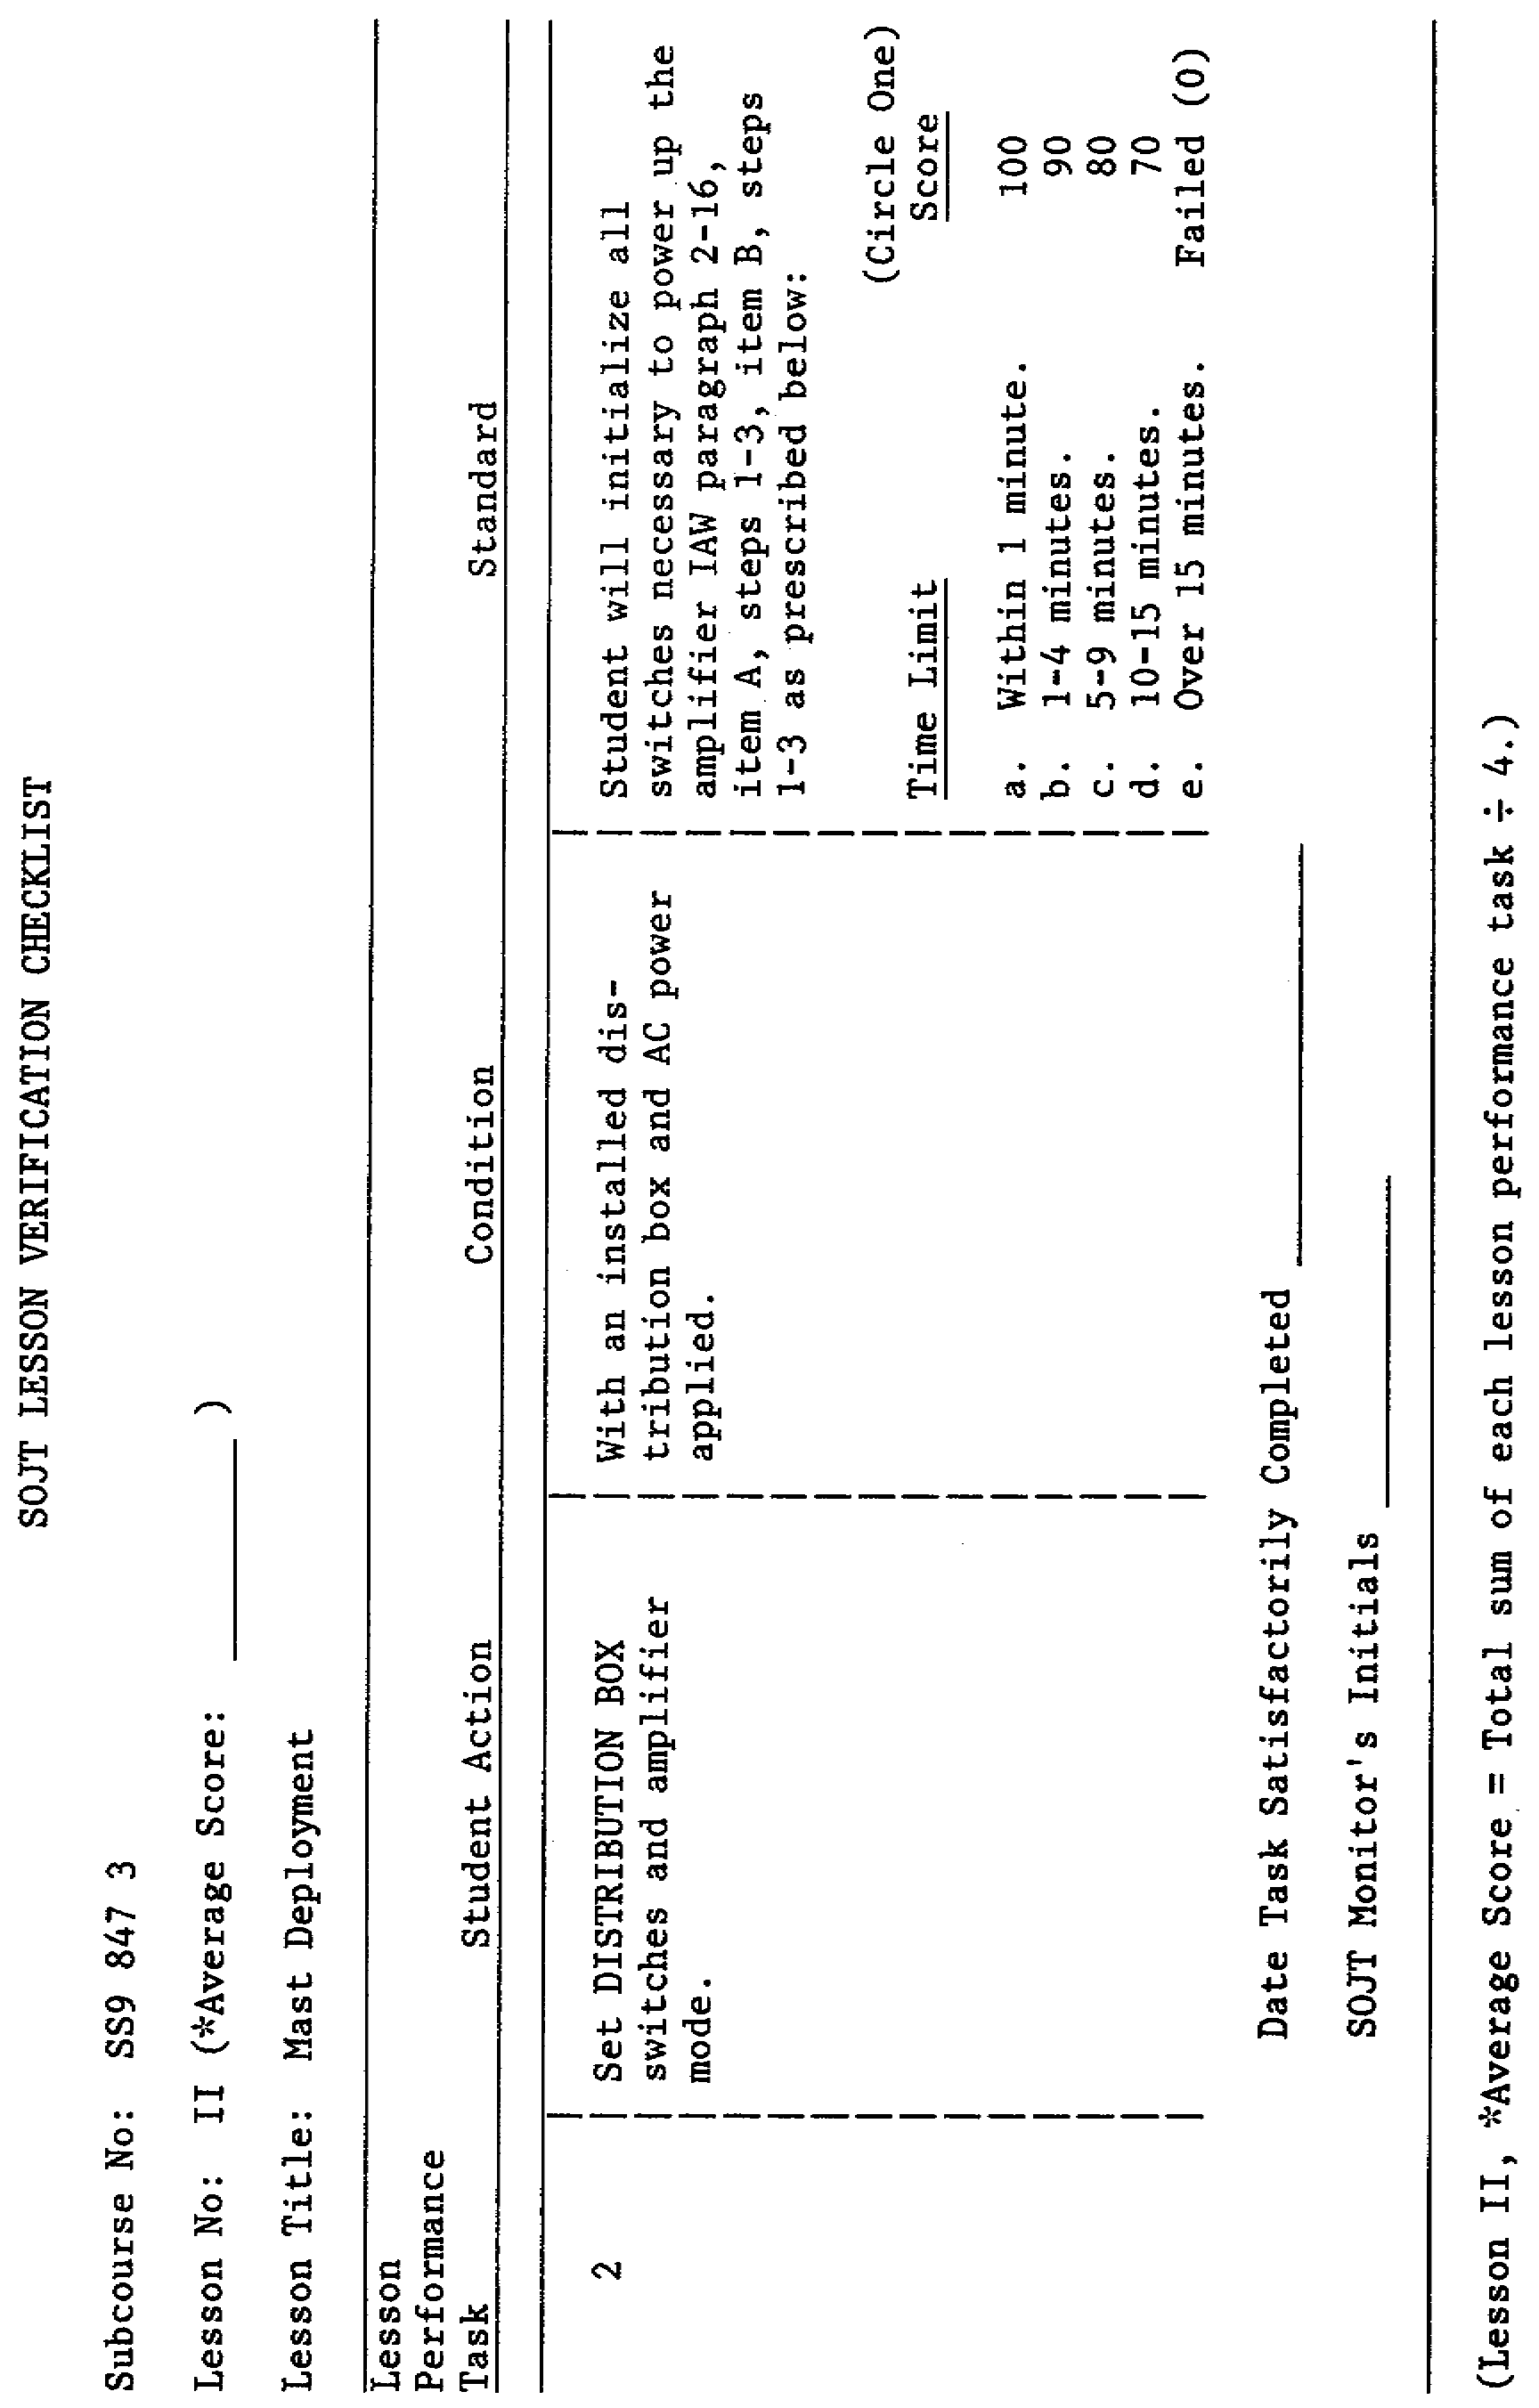
10

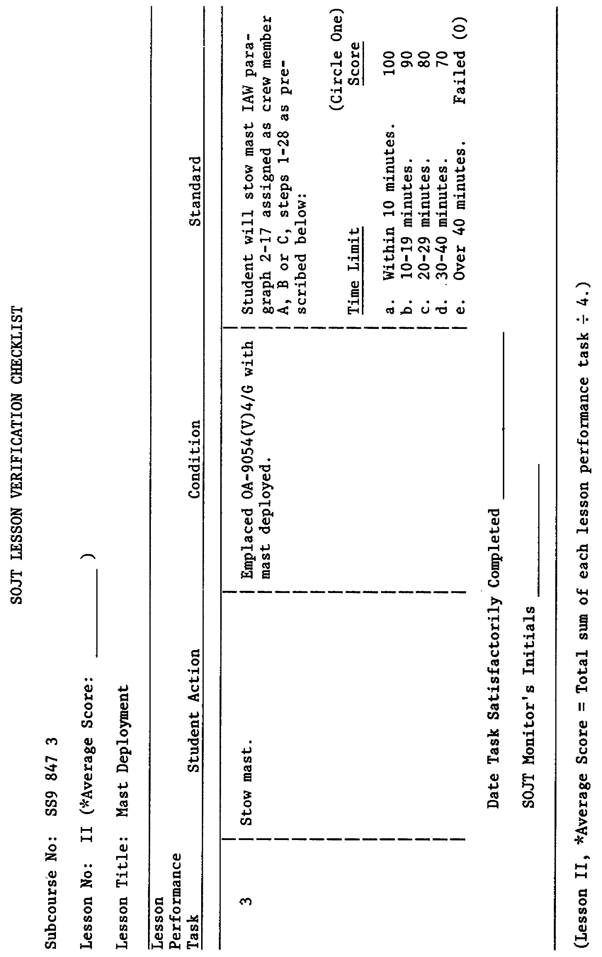
11

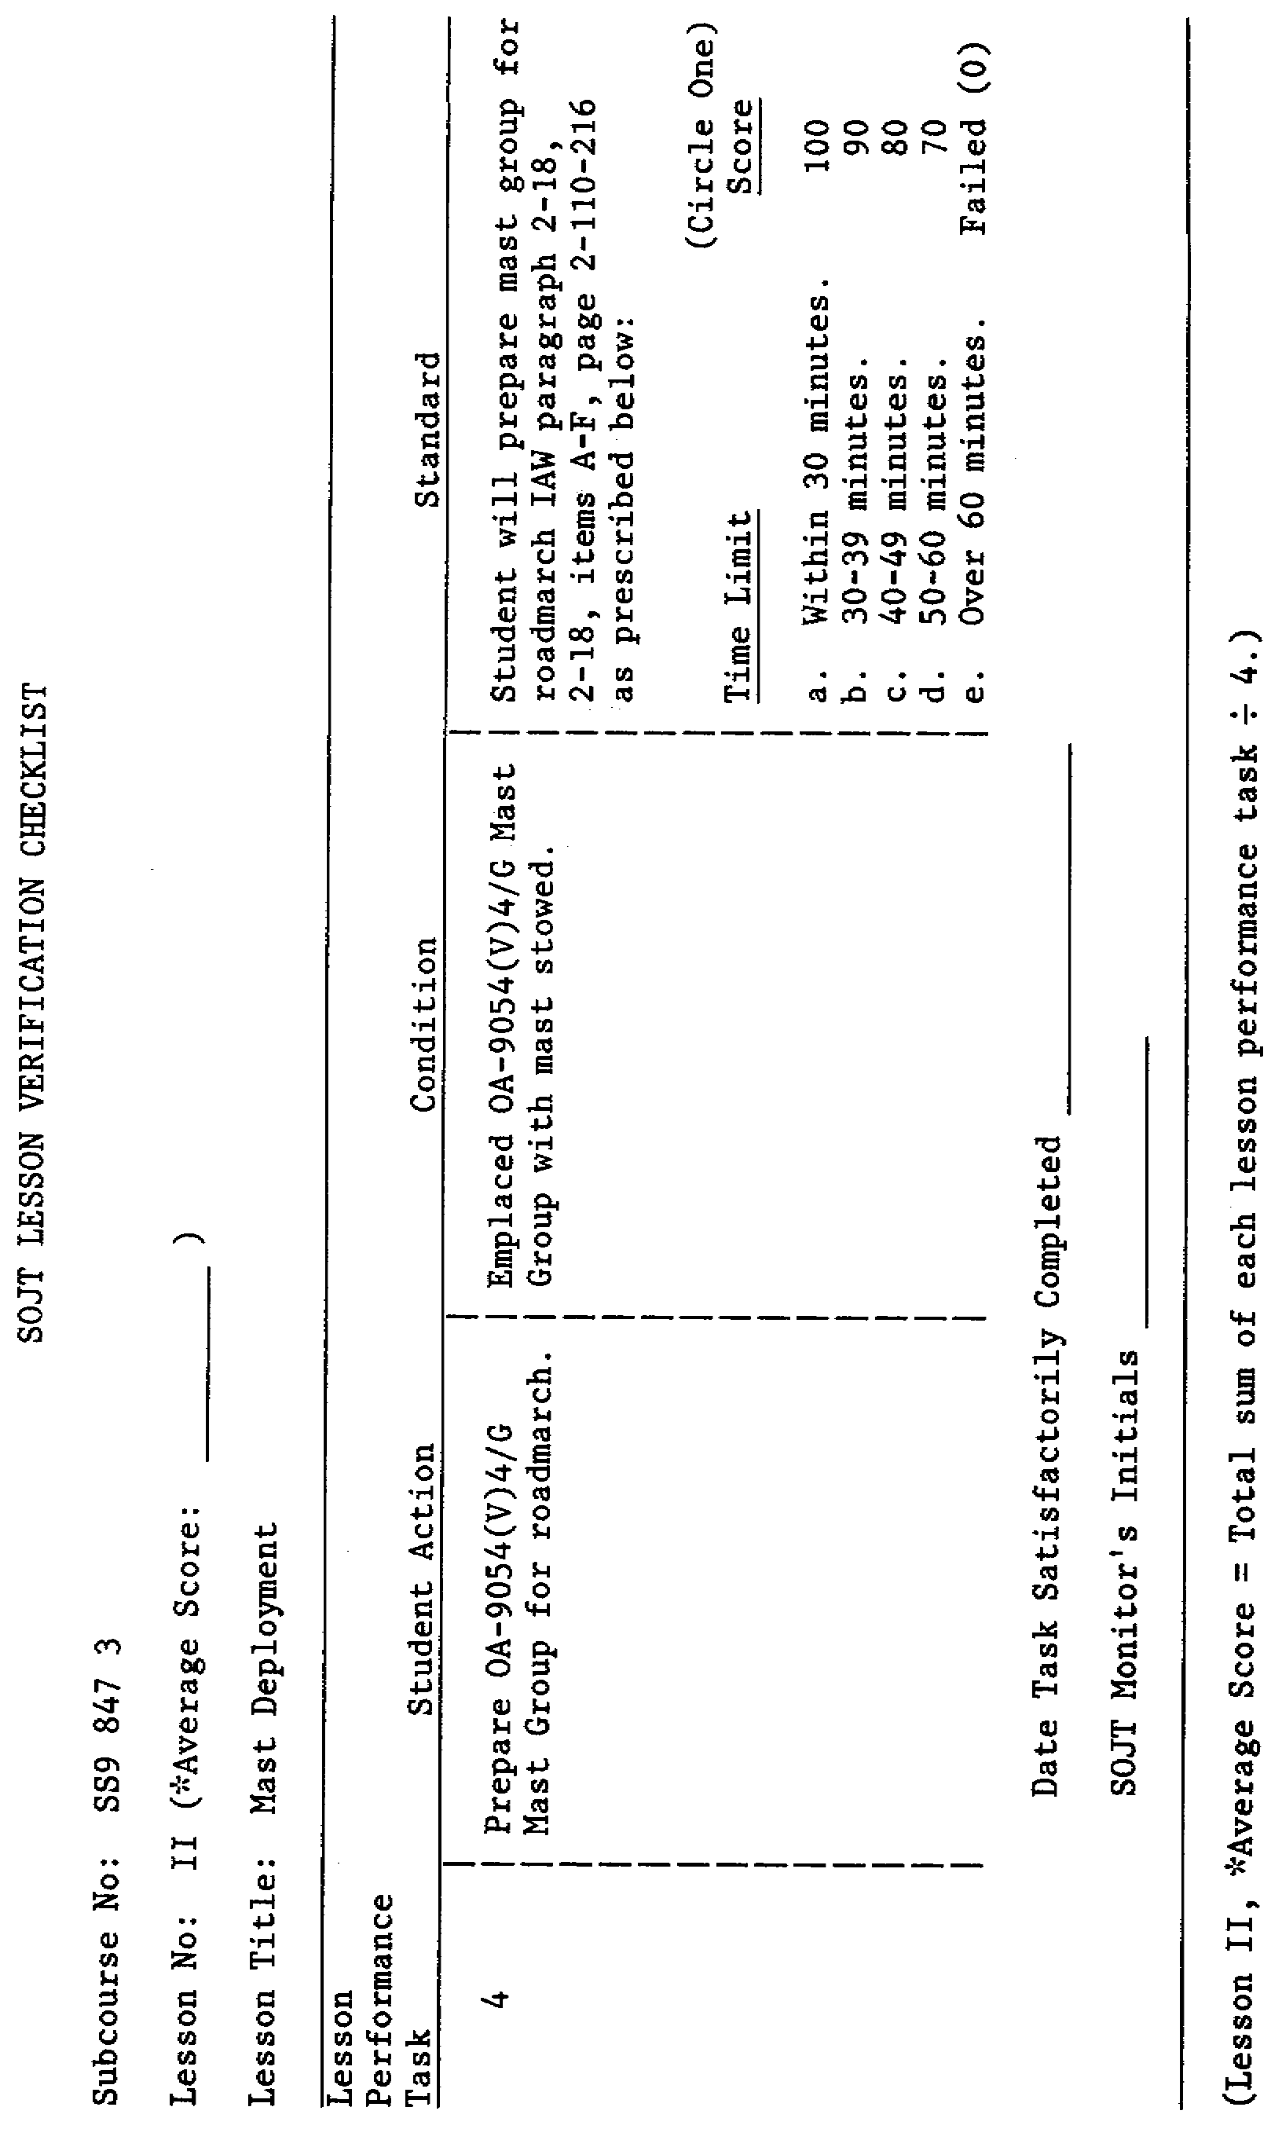
12

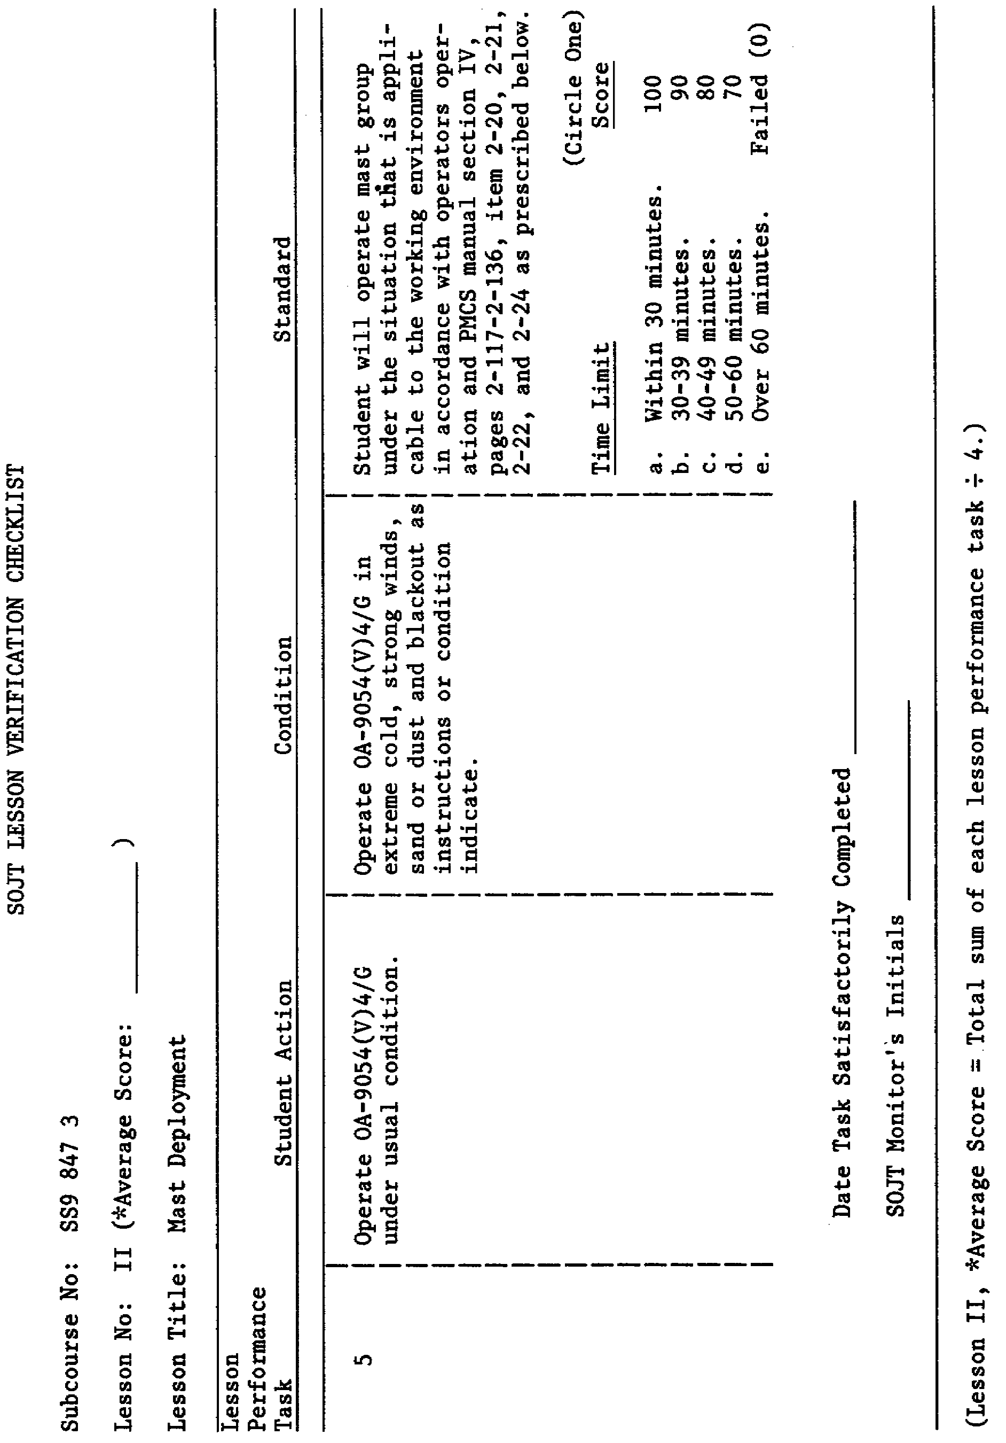
13

